For immediate release November 7, 2022

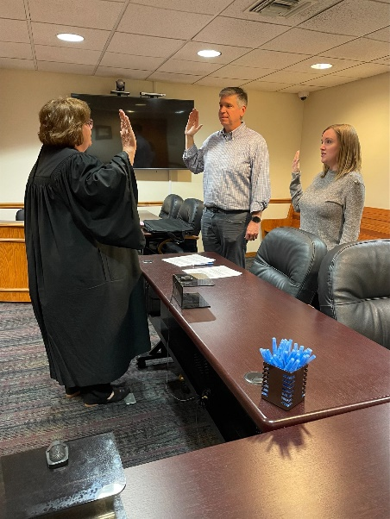

CASA/GAL of Hancock County Swears in Volunteers
Findlay, OH- In a private court ceremony, Hancock County Probate and Juvenile Court Judge Kristen Johnson swore in two of CASA/GAL of Hancock County’s newest volunteers. Adam DeBoskey and Ashley Bell were both sworn in on November 3, 2022 and are now ready to help the children in Hancock County. The mission of CASA is to support and promote court-appointed volunteer advocacy so that every abused or neglected child can be safe, establish permanence, and have the opportunity to thrive. “It’s great being able to advocate for the children of Hancock County. There is such a huge need for volunteers in this program, and I am happy to do my part and support these children” Bell said. Bell recently took the position as the Executive Director of the program in early October. Volunteers are required to complete 30 hours of pre-service training as well as 12 hours per year of continuing education courses. CASA of Hancock County will be holding its next pre-service training in January of 2023. If you are interested in joining this call please contact Ashley Bell at 419-424-7011 or by email at aibell@co.hancock.oh.us

